Automated Test Framework User Guide
Version 1.8
Author: Mike Zhao

Content
Revision history 1
1. Introduction 5
2. Framework structure 5
3. Configuration 8
4. Usage 8
5. Functions 10
6. Advanced Features 14
6.1 Warning Status to ignore failed steps 14
6.2 Run by case priorities 15
6.3 Debug Mode 15
7. Performance Test Automation 15
8. Test Report 16
9. Upgrade 16
9. How to develop tools interface to integrate into ATF 17
10. FAQ 17

Revision history
Name | Date | version | Summary of changes
Mike Zhao | Nov 10, 2010 | 0.1 | Draft
Mike Zhao | Dec,7,2010 | 0.2 | Updated with new features:  a. Check point for each test step.  b. Test result and log analysis.  c. Test report generation in XML/XSL.
Mike Zhao | 4,Jan,2011 | 0.3 | Updated with new features:  a. Merge detailed error info into XML test report.  b. Do investigation and improve log feature to support "run command on new shell" can be logged.  c. Improve the file/folder sync function, added two new functions: GetLatestFile / GetLatestSeveralFiles
Mike Zhao | 11,Feb,2011 | 0.4 | Updated with these items:  a. Add a new function called “GetLatestFileByKeyWords”.  b. Add a new function called “GetLatestSeveralFilesByKeyWords”.  c. Fix the issue of RunScriptOnNewShell from Local server.  d. Improve the layout of automation test report.  e. Update the interface between ATF and File Analyzer tool, “Test Case #” is the key word of ATF now.
Mike Zhao | 1,April,2011 | 0.5 | Updated with these items:  - Auto Upgrade Test Cases  - New APIs:  RunScriptOnNewShellNoLog - Run a script on new shell with no log  GetLatestFile – both copy from local mount and remote  GetLatestSeveralFiles – both copy from local mount and remote  GetLatestFileByKeyWords – both copy from local mount and remote  GetLatestSeveralFilesByKeyWords – both copy from local mount and remote  Mount – Mount a remote drive  Unmount – Mount a remote drive  RunCmdOnNewShell - Run a command on new shell  RunCmdOnNewShellNoLog - Run a command on new shell with no log  GenerateScript – Customize your own script  Restart - Restart remote server  - Updated report style sheet to render better.  - Add a new feature to let the users set “Test Automation Report Format”, you can choose to render “Detail Info” or “Summary and Detail Info”.  - Add Comments column in test case file, you can merge multiple cells for step description if needed.  - Developed Sync File Script To improve the efficiency of test cases development using ATF.  - Developed Init authentications script to improve the efficiency of building up OpenSSH server/client authentications for the first time running.  - Improve the performance of job execution.
Mike Zhao | 17,May,2011 | 0.6 | Updated with these items:  - Added two new APIs:  FileExist – To identify if the file is existing as expected.  ManualStep - This is a comment API for describe the test steps.  Currently 28 APIs for team reuse in total.  - Update RunCommand API to support space and comma as parameter separator.  - Update all get latest file function to support rename copy from both local and remote.  - Add more details about developing tools interface to integrate with ATF.
Mike Zhao | 08,June, 2011 | 0.7 | Improvement list:  - Trim Space for parameter list.  - Update RunScript APIs to support execution on Solaris.  - Remove the info “mkdir: cannot create directory” if directory already exists  - Improve the performance of job execution.  - Auto close windows when running RunCmdOnNewShellNoLog.  - Improve the RunCommand status judgment rule:  a. Getting the command execution result and report “Error: This command was executed failed!”.  - No any output on console will get pass result.  - Remove the pending status when job finished.  - Rename copy from both local and remote are supported in GetFile / GetLatestFile / GetLatestFileByKeywords  Bug fix list:  - IP address display for Win2003 and Win2003R2 on test report.  - RunScriptonNewShell issue for multiple parameters.  - GetLatestFile APIs is not stable for syncing files.
Mike Zhao | 07, July, 2011 | 1.0 | 1. New Feature List  - Display server name for each steps on console.  - Improve execution performance of sync file APIs(GetFile / GetLatestFile / GetLatestFileByKeyWords / GetLatestSeveralFiles / GetLatestSeveralFilesByKeyWords)  - Improve Unmount API to force remove remote driver.  - Improve execution performance of NewShellNoLog APIs (RunCmdOnNewShellNoLog / RunScriptOnNewShellNoLog).  - Add a new API called SmartSleep, it will detect if all jobs on new shell have finish executing, if yes, it will continue to the next step, and no for sleep more time until they finish. It is useful when you run command / scripts on new shell for a long time, you don't need to use sleep to wait for a longer time, this will improve the efficiency.  - Add a new feature called customized error keyword, you can define your own error keywords, if the keywords displayed on console, ATF will catch it and mark as Failed result in test report.  - Improve test case debugging method, the steps will be disabled if comment column contains -1.  2. Bug Fixing List  Update all newshell APIs to support multiple parameters execution on both local and remote servers with path contains space.  3. Build Up System Testing Template For Regression Test Before Release  Created 115 System testing steps to verify ATF APIs functionalities.
Mike Zhao | 25, Aug, 2011 | 1.2 | 1. New Feature List  - Display execution duration time of each case on test report.  - Update Start/Stop Services (local and remote) to return pass result if the service already started/stoped before running this job.  - Improve the performance for job execution.  - Update RunScript and RunScriptOnNewShell APIs to support local and remote execution without separators.  - Set Ignore feature in comments column, add a new status Warning, failed steps will be ignored and marked with Warning in case result.  You just need to mark the test step with <W> in Debug/Ignore/Comments column.  - Update Start/Stop service APIs to support both ServiceName and DisplayName on local and remote.  - Automation Test Cases running by case priority.  You can mark the test cases with different priorities in TestSuite tab and run like this:  Runatf 0  Then the test cases with priority 0 will be executed.  - Develop a new API called ProcessMonitor, it will detect if a remote process is existed or not on local or remote.  It is able to check if the process is existing as expected or wait for the specified process until exit.  - Update GetFile API to support wildcard both from local and remote server.  - Develop a new API called RemoteFileCopy, you can copy file from one remote server to another.  - Develop a new API called RemoteFolderCopy, you can copy folder from one remote server to another.  2. Bug Fixing List  - Fixed the pending issue for getFiles APIs when remote folder contains many files.  3. Updated System Testing Template For Regression Test Before Release  Created 142 System testing steps to verify ATF APIs functionalities.
Mike Zhao | 12, Dec, 2011 | 1.8 | - Performance Test Automation.  ATF can detect the sending traffic rate limit (Max processing capability) automatically.  Example:  Rate: 10K -> Pass  Rate: 11K -> Pass  Rate: 12K -> Fail  Rate: 11.5K -> Pass  Rate: 11.75K -> Pass  Rate: 11.875K -> Fail  Limit Range: 11.75K ~ 11.875K  - Const Define feature to implement macro replacement in cases.  This feature is very useful, you can define environment variables, IP/Ports, long file/folder path.  - Easy Debug – you don’t need to mark “-1” in comments column again, just run like this:  RunATF.bat d20, then it will run from row 20.  - Auto grant execution permission when uploading files/folders in 2 APIs.  - RemoveFile API supports wild card on both local and remote servers.  - RemoveFile and RemoveFolder API don't report error but warning if file/folder does not exist.  - CI integration is ready, just add runatf.bat in Jenkins/Hudson configuration.  - Update GetFile to support rename copy on both local and remote servers.  - Archive test report to customized location.

1. Introduction
This framework is to implement multiple servers interactive testing, remote file/folder sync and remote command execution. You just need to choose the action/step you want to run from dropdown list in excel, specify the test server and then run it. You don’t need to make a lot of configuration on test servers so it is very easy to use.

2. Framework structure
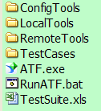

ATF
├─ATF.exe – It is the main application for framework.

├─RunATF.bat – Please run this bat file to run the framework, it will generate ATF_log.txt under the root folder dynamically and generate test report when test finished.

├─TestSuite.xls – It is test case, test server and test configuration management file. It has several worksheets:
a. “TestSuite” worksheet, we can list all test cases here, and if you want to run them, you just need to choose Enable from Status dropdown.
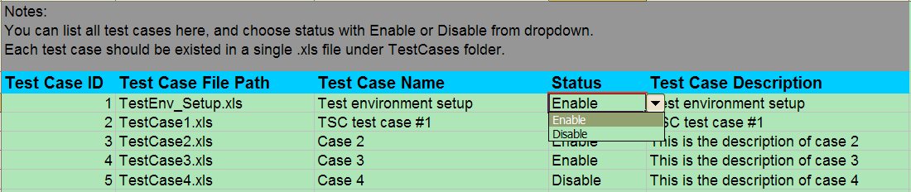

b.“ServerPool” worksheet, we can list all test servers information here, then the framework will read these info and logon to the remote servers to implement remote command execution. You need to list the correct Server NO by sequence.
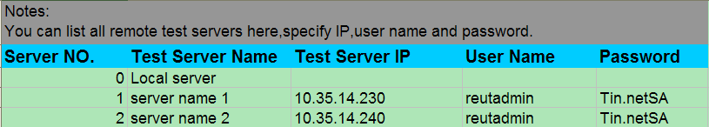

c. “TestConfig” worksheet, we can define test run configuration like time out or local test result folder location here.
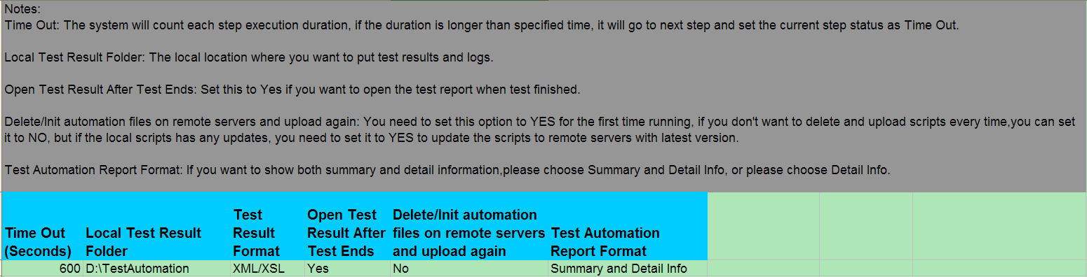

d. “Performance” worksheet, it is for performance testing, you can define variable and config here. Please see the worksheet notes for detail.
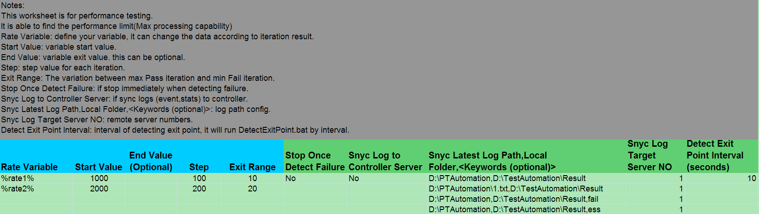

e. “ConstDefine” worksheet, you can define the const name and value, then the consts appeared in all test case files will be replaced. You can define environment variables, IP/Ports, long file/folder path.
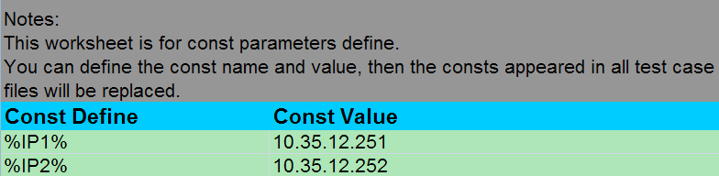

f. “Pre-condition” worksheet, if we need to stop services or kill processes on all test servers, we can add a step here.
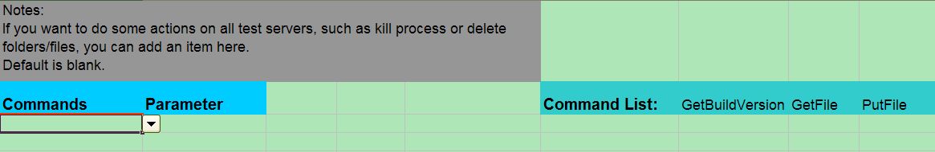

├─LocalTools – Stored all scripts/applications/tools which will be run locally, this folder will NOT be distributed to remote test servers.

├─RemoteTools – Stored all scripts/applications/tools which will be run remotely, this folder will be distributed to each remote test servers so the scripts under this folder can be run on remote servers. You can just copy the scripts to this folder and the framework will distribute your customized scripts to remote servers automatically.

└─TestCases – Stored all test cases, each test cases is organized in a single excel file. We can edit and describe the test steps in “Tasks” worksheet from each xls file. You just need to create a new line, specify command, parameter and server NO (defined in ServerPool).
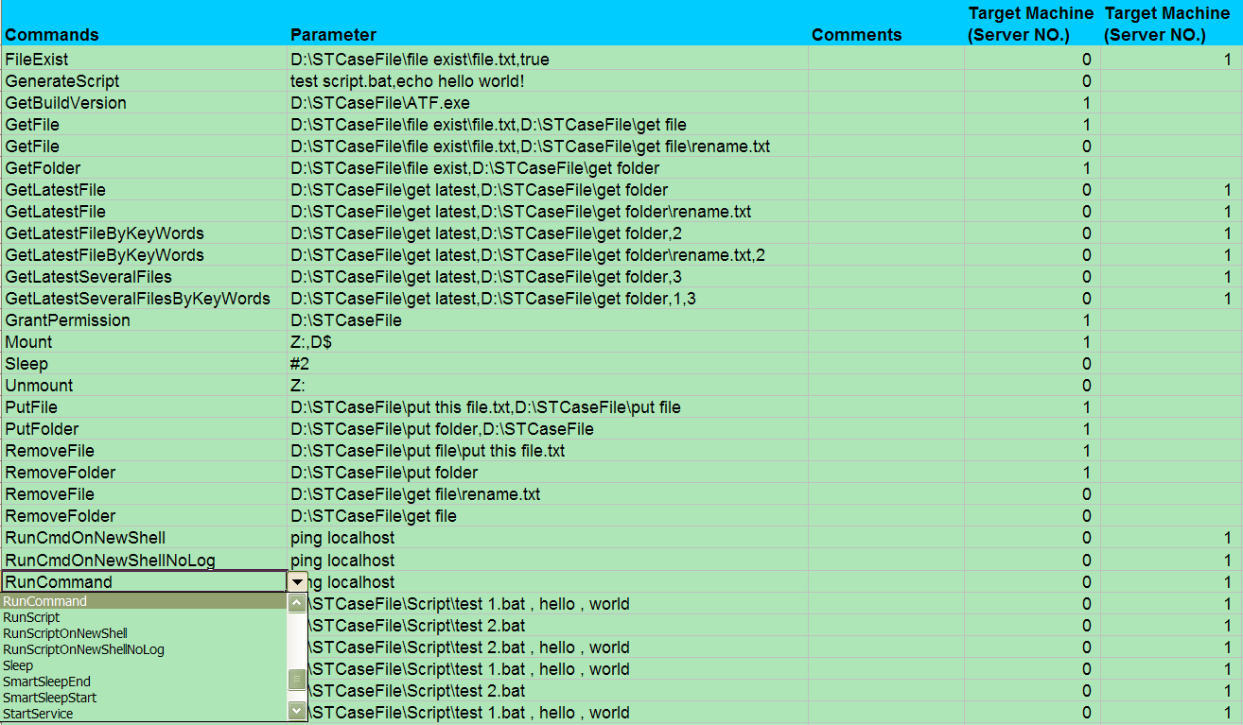

3. Configuration
  - OpenSSH server on remote test servers
You can easily check if the server has already installed OpenSSH by two methods:
Check service list to see if OpenSSH Server is existing
or check process list to see if sshd process is running

If NOT, you need to install OpenSSH by following steps:
- You need to install OpenSSH server on each remote test servers, you don’t need to install on local controller server. You can get the OpenSSH installer setupssh.exe under ConfigTools folder.
- Then you need to copy cygintl-2.dll to C:\Program Files\OpenSSH\bin
- Open quickstart.txt under C:\Program Files\OpenSSH\docs and make some configurations following the steps in “configuration” section.

  - net framework 2.0 on local controller server
First you can check if your controller server has installed .net framework 2.0 by following step:
Start->Control Panel->Add or Remove Programs and see if .net framework 2.0 is existed.

If Not, you need to install .net framework 2.0 before running the framework, you can find the installer file dotnetfx.exe from ConfigTools folder.

  - Network
Make sure all remote test servers are able to be pinged successfully from local controller machine.

  - Store host keys on remote servers
To improve the performance of connecting each servers for the first time, you need to edit Init_Auth.vbs with each remote servers information (see comments in Init_Auth.vbs). Then run the vbs. You don’t need to do that next time.

  - Open XML with IE
If you can open XML in IE by double clicking XML file, you do NOT need to do this.
Otherwise, please right click xml file->Open With->Choose Program->Select “Internet Explorer” and check “Always use the selected program to open this kind of file”.

4. Usage
- Copy the framework files/folders to local controller machine (can be any machine even Virtual machine).
- Make sure you have finished all configurations (see section 3 for detail).
- Open TestSuite.xls and go the TestSuite worksheet, edit your test case list, if you want to run the test case, set the status to Enable. If you changed the file names in “Test Case File Path” column, you need to rename the files under TestCases folder as well.
- Go to ServerPool worksheet, edit your remote test server list. But do NOT delete the local server.
- (Optional) You can edit TestConfig or Pre-condition worksheet if needed.
- Open Test case file under TestCases folder, edit your test steps.
You can open TestCaseUpgrade.xlsm and choose Function Reference tab to get detailed sample for each functions.
  - If you want to add more than 1 parameter in Parameter column, separate with ‘,’.
  - If you want to run a command with parallel mode, choose “RunCmdOnNewShell”, for script, choose “RunScriptOnNewShell”.
  - If you want to delete one or more step(s), select the row(s) and right click to choose delete menu item. Please don’t just press delete key as there is a Microsoft issue for Excel data driver.
- (Optional) If you want to run your external scripts or tools on remote servers, copy them to RemoteTools folder and add a new item “RunScript” in Command column , type <script/tool full name> in parameter column and specify the target machine.
If the tools or scripts have existed on your remote servers already, you just need to specify the FULL path of them in parameter column.
- Then you can launch the framework by running:
Double click RunATF.bat or open a cmd window to run RunATF.bat
- You can see the execution result once finished, and you can also check ATF_Log.txt for archiving. (This txt log will be overwritten by next time running, but you can see the XML log under <Local Test Result Folder>\Report folder.

I created notes for each tab in TestSuite.xls and created function reference sheet in TestCaseUpgrade.xlsm, you can get more detailed instructions from them.

5. Functions
Currently these functions are supported:

Function Name | Description | Parameter Example | Target Machine
FileExist | To identify if the file is existed as expected. It has two parameters, the first one is file full path (from local or remote), the second one is the existence flag, if you expect the existance, set it as true, otherwise set as false. | E:\run.log,true | Local or Remote
GenerateScript | Generate your customized script, you can generate from controller and then upload it to remote server, grant an execution privilege and run it on remote server. It has two parameters, the first one is script name, the second is script content. | Myscript.bat, content | Local
GetBuildVersion | You can extract build version from any .exe or .dll file, just need to specify the FULL path of file. | C:\app.exe | Remote
GetFile | Copy a file from remote server to local(or mount to local), you need to specify two parameters: the first one is source file's FULL path, the second one is destination folder's FULL path. It supports rename for both local and remote. | D:\RemoteTest\test.log,E:\LocalTest  Z:\Remote\test.log, D:\Local  D:\Local\test.log,Z:\Remote\rename.log | Local or Remote
GetFolder | Copy a folder from remote server to local(or mount to local), you need to specify two parameters: the first one is remote folder's FULL path, the second one is local folder's FULL path. | D:\RemoteTest, E:\LocalTest | Remote
GetLatestFile | To get the latest updated file from remote server folder. It has two parameters, the first one is remote folder's FULL path, the second one is local folder's FULL path.It supports rename for both local and remote. | D:\RemoteTest, E:\LocalTest\rename.txt | Local or Remote
GetLatestFileByKeyWords | To get the latest updated file by key words from remote server folder. It has three parameters, the first one is remote folder's FULL path, the second one is local folder's FULL path, the third one is key words.It supports rename for both local and remote. | D:\RemoteLogFolder,D:\LocalSync\rename.txt,key | Local or Remote
GetLatestSeveralFiles | To get several latest files (the number needs to be specified in parameter list) from remote server folder. It has three parameters, the first one is remote folder's FULL path, the second one is local folder's FULL path, the third one is the number of files you want to copy. | D:\RemoteTest, E:\LocalTest,5 | Local or Remote
GetLatestSeveralFilesByKeyWords | To get the latest updated file by key words from remote server folder. It has three parameters, the first one is remote folder's FULL path, the second one is local folder's FULL path, the third one is key words,the forth one is the number of files you want to copy. | D:\RemoteLogFolder,D:\LocalSync,key,3 | Local or Remote
GrantPermission | Grant read/write/execution permission for a folder from remote server. | D:\RemoteTest | Remote
ManualStep | This is a comment API for describe the test steps, you don't need to fill parameter and target machine | N/A | Local or Remote
Mount | Mount a drive on remote server.It has two parameters, the first one is local drive volume, the second is remote folder you want to mount. | Z:,D$ | Remote
PerfCheckWaitTime | It is used for performance test, you can set the interval to invoke DetectExitPoint.bat by interval. Example: if you set #10, it will detect exit point every 10 seconds. | #10 | Local or Remote
ProcessMonitor | Detect if the process on remote or local is existing or not.  The first parameter is the process name, if you type the second parameter with "true" or "false", it will check if the process is existing as expected.  If you don't type the second parameter, this function will wait for the process until exit. | traffic.exe,true  traffic.exe,false  traffic.exe | Local or Remote
PutFile | Copy a file from local(or mount to local) to remote server, you need to specify two parameters: the first one is local file's FULL path, the second one is remote folder's FULL path. It will grant executable permission automatically. | Windows: E:\LocalTest\test.log,D:\RemoteTest  Unix: E:\LocalTest\test.log,/reuters/ThomsonReuters | Remote
PutFolder | Copy a folder from local(or mount to local) to remote server, you need to specify two parameters: the first one is local folder's FULL path, the second one is remote folder's FULL path. | E:\LocalTest,D:\RemoteTest | Remote
RemoteFileCopy | Copy one or several files(wildcard supported) from one remote server to another one,it has 4 parameters:  the first one is source file full path, the second is source server NO, the third is destination folder path, the forth one is destination server NO. | D:\STCaseFile\IDN*.txt,1,D:\STCaseFile\RemCopy,2  D:\STCaseFile\1.txt,1,D:\STCaseFile\RemCopy,2 | Local
RemoteFolderCopy | Copy a folder from one remote server to another one, it has 4 parameters:  the first one is source folder full path, the second is source server NO, the third is destination folder path, the forth one is destination server NO. | D:\STCaseFile\files,1,D:\STCaseFile\RemCopy,2 | Local
RemoveFile | Remove a file or some files on local or remote servers.(wild card supported), if the file doesn't exist, it will show as a warning rather than fail. | D:\RemoteTest\test.log  D:\RemoteTest\IDN*.log | Local or Remote
RemoveFolder | Remove a folder on local or remote servers, if the folder doesn't exist, it will show as a warning rather than fail. | D:\RemoteTest | Local or Remote
Restart | Restart a remote server | No parameter | Remote
RunCmdOnNewShell | Run a command on new shell under parallel mode. | net start smf | Local or Remote
RunCmdOnNewShellNoLog | Run a command on new shell under parallel mode. | net start smf | Local or Remote
RunCommand | Run any OS commands like ipconfig,systeminfo. | ipconfig | Local or Remote
RunScript | Run any external applications or scripts, you need to specify the FULL path,or if you have put it under RemoteTools folder,just specify the file name. | D:\RemoteTest\setup.bat | Local or Remote
RunScriptOnNewShell | Similar to RunScript but difference is that this will create a new shell window to execute the application/script, so we can run them under parallel mode. We can use this function when launching wireshark. | D:\RemoteTest\setup.bat | Local or Remote
RunScriptOnNewShellNoLog | Similar to RunScript but difference is that this will create a new shell window to execute the application/script, so we can run them under parallel mode. We can use this function when launching wireshark. No log will be recorded. | D:\RemoteTest\setup.bat | Local or Remote
Sleep | Wait some time (seconds), you need to specify the time by using these format: #time | #3 | Local or Remote
SmartSleepEnd | To detect if all jobs on new shell have finish executing, if yes, it will continue to the next step, and no for sleep more time until they finish. It is useful when you run command / scripts on new shell for a long time, you don't need to use sleep to wait for a longer time, this will improve the efficiency.  You don't need to use this API if new shell execution time is shorter than 5 seconds.  For local new shell (Target server is local), please use cmd,<cmd instance number>.  For remote new shell, please use plink,<plink instance number>  It does NOT support both local and remote at the same time so far. | cmd,3 - for local new shell  plink,2 - for remote new shell | Local
SmartSleepStart | To use Smart Sleep function, you need to run it before running new shell APIs, it will record the creation time for any existed cmd or plink process. | No parameter | Local
StartService | Start a service on local or remote servers, you need to specify the service name. | telnet | Local or Remote
StopService | Stop a service on local or remote servers, you need to specify the service name. | telnet | Local or Remote
TaskKill | Kill a process, you need to specify a process name, extension name required. | TSC.exe | Local or Remote
Unmount | Unmount a drive on local server.The parameter is local drive volume. | Z: | Local

6. Advanced Features

6.1 Warning Status to ignore failed steps
If some of test steps are expected to get Fail result, and they do not impact your test workflow and result, you can mark the test step with <W> in Debug/Ignore/Comments column.
Then if the step was failed, it is marked with Warning result and generate pass result for this case if no any other failed steps.
Please see the snapshot below:

Mark <W> in Comments column:
Then the result will be passed:
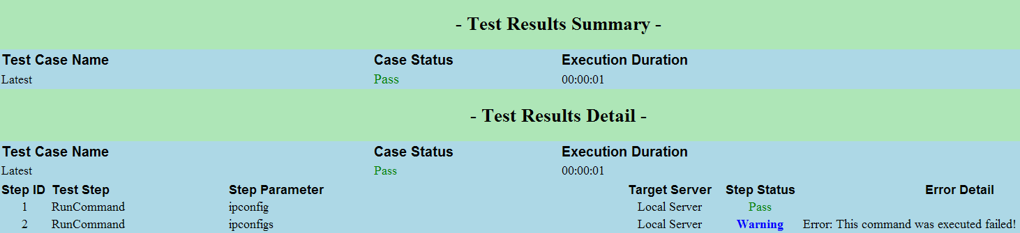
If you already add some comments in this column, don’t worry, just add <W> and the framework will detect if this column contains <W>.

6.2 Run by case priorities
You can mark the test cases with different priorities in TestSuite tab and run like this:
Runatf 0
Then the test cases with priority 0 will be executed.

6.3 Debug Mode
1. You can debug from a specified row without updating spreadsheet, just add an argument when executing RunATF.bat like this:
RunATF.bat d20
Then it will run test from row 20.

2. If you’re trying to debug performance test cases, execute like this:
RunATF P1 d20

3. Another debug method is marking Comments Column or the first Column as -1, then this step will not run.

7. Performance Test Automation
1. Update “Performance” worksheet in TestSuite. You can see notes on top of worksheet.
2. Execute like this:
Single test case:
a. Mark P1 at “Test Case Priority/Performance Mark” column in TestSuite.
b. Update DetectExitPoint.bat. See example.
c. RunATF P1.

Multiple test cases:
a. Mark P1…Pn for each test cases at “Test Case Priority/Performance Mark” column in TestSuite.
b. Open PerfTestSuite.bat and update totalTestCases.
c. Update DetectExitPoint.bat. See example.
d. Execute PerfTestSuite.bat.

8. Test Report
You can get the test report to know the test status, duration, statistics and detailed information. To enable this feature, you just need to set “Open Test Result After Test Ends” to Yes, then the report will be launched from IE window like this:
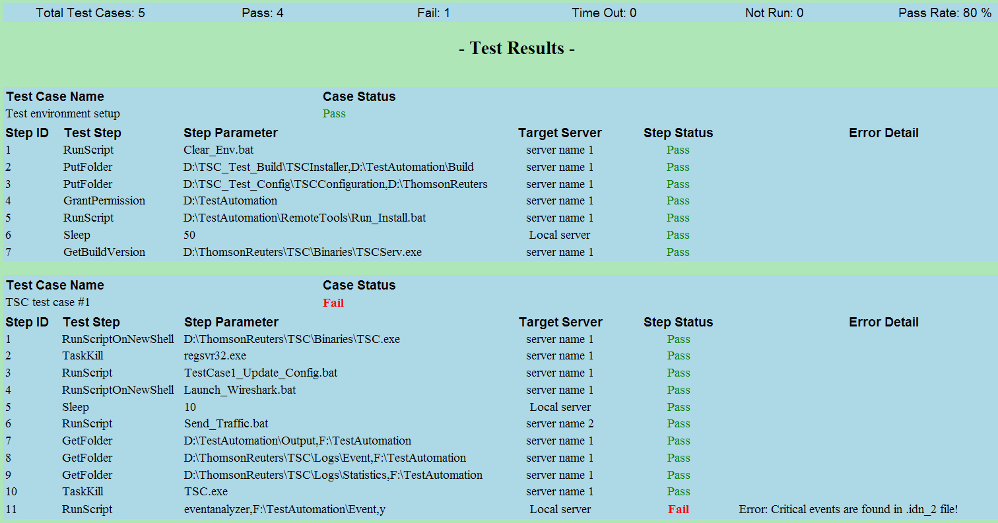

9. Upgrade
9.1 Test Framework Upgrade – One-click upgrade
You just need to double click Upgrade.bat under new ATF root folder (Destination folder is D:\ATF).

9.2 Test Case Upgrade
  - Make sure you have installed Excel 2007, this script does NOT support on Excel 2003.

  - Please backup your test case files first.

  - Open TestCaseUpgrade.xlsm file under ATF root folder.

  - Click “Update Test Cases” button in Main tab.

  - Type *.xls or *.xlsx as extension match type.

  - Redirect to TestCases folder and click OK.

  - Then all test cases file will be updated on Tasks tab, the previous steps will be stored in
LegacyTasks tab.

  - Please note that for Sleep function, you should update with # as prefix. Such as sleep 5,
you need to update with sleep #5. You only need to update once and do NOT need to do this step in the future. The previous rule “=Text(5,0)” is invalid from version 0.5.

  - <Ver1.0’s new feature> To use “Error Keyword Customization” feature, you need to add
a new column in TestConfig tab in TestSuite.xls, please open the latest TestSuite.xls under ATF root folder, and just copy G2 and G3 in TestConfig tab to your previous TestSuite.xls.

  - <Ver1.2’s new feature> To use “Run by Test Case Priority” feature, you need to add
a new column in TestSuite tab in TestSuite.xls, and just type your priorities for each test cases behind comments column.

k.<Ver 1.8’s new feature> You need to upgrade:
a). Open the new TestSuite.xls, copy Performance and ConstDefine worksheets to your previous TestSuite.xls.
b). Append H column for “Archive Test Report To Another Local Place” in TestConfig worksheet.
And Update F column for “Test Automation Report Format” in TestConfig worksheet.

9. How to develop tools interface to integrate into ATF
ATF will detect output string for each step, when finding “Failed” or “Error” keywords, ATF will record this test step as a failed result. If there is no any output, ATF will record as a PASS result, so if your check point is failed, you just need to print “Failed” or “Error” keywords on console.

Of course you can define your customized error keywords in TestConfig tab in TestSuite.xls. This is global setting and applied to all APIs.

10. FAQ
  - If we need to run GUI based application, how to do?
Currently OpenSSH Client Plink does NOT support interactive session, please see detail below:
Plink (PuTTY Link) is a command-line connection tool similar to UNIX ssh. It is mostly used for automated operations, such as making CVS access a repository on a remote server.
Plink is probably not what you want if you want to run an interactive session in a console window.
You can get more information from page:
http://the.earth.li/~sgtatham/putty/0.58/htmldoc/Chapter7.html

We’ll find another solution for how to run GUI based application, please let me know if your project has such kind of requirement.

  - Does this framework support Excel 2007(.xlsx)?
Yes, you can use either Excel 2003 or 2007 to manage your test cases.

  - Why I experienced “Cannot access ‘TestSuite.xls’ or’TestCase.xls’”?
That’s because you have started running the framework, after that, you are not able to open the Excel files as they are using by framework process. You can stop running the framework and then open the Excel files.

  - Do I need to install Excel application on controller?
NO, you just need to copy all xls files to controller, you can NOT edit test case without Excel but you can run it.

  - My execution result has timeout items, how to resolve it?
That’s because your execution time is longer than you have set (Time out). You just need to update a longer timeout time (like 10000) in Time out field in TestSuite.xls.

  - I list several remote servers in target columns but ATF did not run the step on every server, how to resolve it?
You just need to select the target machine columns and right click->Format Cells->Choose Number with 0 decimal place and save it.

  - During test cases debugging period, I don’t want to run some steps, how to do?
Method 1:
You can debug from a specified row without updating spreadsheet, just add an argument when executing RunATF.bat like this:
RunATF.bat d20
Then it will run test from row 20.

Method 2:
You can easily mark -1 in Comments or First Target Machine Column. For comments column, you can add the steps comments and just need to append -1, ATF will detect if the column contains -1.

